Power of Pie Follow-up Survey to Pie Buyers
Sent on 12.3.2014 to 421 email recipients
94/421 =22% Response Rate
1.
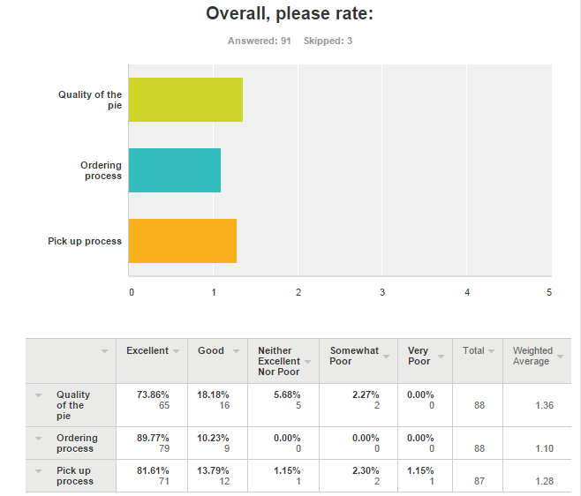
Comments:
- I had a little trouble finding the pick up location, perhaps there could be a signs pointing / indicating where the pickup spot is near the main street. The pie was DELICIOUS.
- Everything in the whole process is great, I love it!
- One of the most satisfying experiences, charitable giving or for profit, that I've ever had!
- Pecan pie from the Rosewood Mansion was the best pecan pie I've ever tasted.
- A pick up window from 2 to 5 p.m. is not reasonable for folks who work. I could not pick it up over lunch or leave work early, before you closed. I also preferred picking up the pie in a location closer to my neighborhood, as I had done the year before. I spent nearly 90 minutes driving to pick up my pie. I would pay extra to have it delivered.
- best pecan pie I have eaten and I bake a good one!
- Pumpkin pie just not very good. Too much nutmeg and soggy crust
- Pie was very delicious!!! Will order again next year!
- Pecan pie from Spoon was superb. The pumpkin pie wet on the bottom. We followed instructions how to prepare. Do not know where the pumpkin pie came from.
- Donated mine so have no idea about the taste.
- There was only one sign at St. Michael's and it was deep inside the building (just outside of the door where the pies were being distributed). It was very confusing to know which entrance to go in and where to go once you were in the building.
- We ordered one pumpkin and one pecan pie, and they both were a huge hit! Delicious!
- went to incarnation to pick up on 11/26, but they had already closed & left. luckily, was able to go to st. michael's
- The pecans on the pecan pie were not toasted but should have been.
- My daughter is on the teen board- it would be nice if there was a place on the order form for the teen's name who solicited the sale.
- None
- Pie was gorgeous and delicious, wish I knew who made it
- Good experience
- Would like a pickup location closer.
- The pies were absolutely marvelous. It was a super way to provide outstanding desserts and do good simultaneously.
- I am sure the pies were delicious but nothing beats being able to participate with a donation ONLY! Less calories - just as filling to the soul!
- We purchased two pies. One was undecorated but "excellent." The second was nicely decorated but only "good." We prefer the excellent pie since we put whipped cream on it anyway.
- I just made a donation without a pie
- One pie was excellent and one was ok. Still so happy to do it!
- Starting the project in earlier months would be great, might have an opportuntity for more buyers.
- While the quality of the pumpkin pie filling was very good, the crust was disappointing and appeared to be a pre-made, low quality crust that truly cheapened the taste and presentation.
- Pecan pie was good size, beautiful presentation but the pie had no taste. It was like they forgot to add sugar or something ...
- We will definitely make this a part of our Thanksgiving tradition. Our pie (from The Mansion) was as delicious as it was beautiful and the entire process was so easy and well organized. I'm delighted you were able to raise such a significant amt. of $ for the VNA.
- The time window for picking up the pies might be expanded and possibly more than 1 site.
- Somewhat poor for the pecan, as it was not very good. No one liked it. Store bought might have been better. We threw away over 3/4 of the pie. Excellent fort he pumpkin pie, it was delicious. Beautiful crust, even the non pumpkin pie eaters ate some!
- Best pumpkin pie I've ever had!
- The pie last year was beautiful. This one was a little disappointing. We are happy to help, but it was not the quality that we received last year.
- We were early for pickup by a few minutes, but were accommodated quickly and efficiently. Pie was EXCELLENT!
- The site where I picked up the pie was too far from my house. Last year I picked up from my church white rock umc and it was close to me.
- I thought the pecan pie would be larger. I could get a much larger pie at Sam's Club or Tom Thumb for about $13.00. I know it is for charity, but I thought I would get more for that large of a price per pie.
- We were out of town, so I ordered the zero calorie pie. Don't know about the taste or pick up process. Ordering was easy!
- Very smooth process
- quality and pick-up questions are N/A, I ordered a "donation only" pie

2.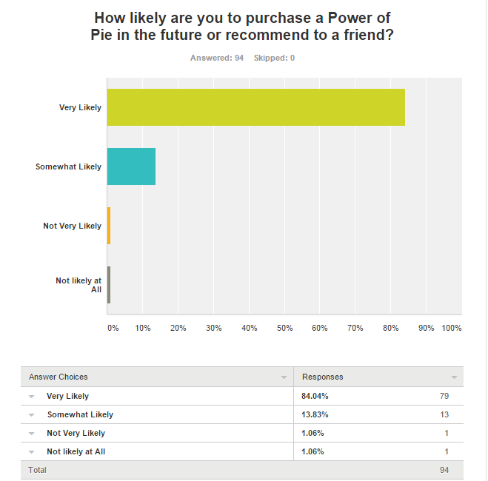

Comments:
- My family loved the pies told I should have purchased more and wanted to know if I could get them for Christmas.
- Loved the pecan pie!
- I would be more likely to do this if the pick up process is improved.
- Like to support VNA
- I sent emails to 50 friends... Don't know how many of them actually purchased a pie.
- It could not have been easier, and the quality is superb. Plus, we wholeheartedly support the organization. We'll definitely do this again!
- Recommended this year but was also trying for the first time had a delicious pie & will definitely recommend next year.
- None
- looking forward to the next event
- My pumpkin pie had gritty stuff in it. I felt like I was eating small pieces of glass in the pie. I am sure it was not glass, but as I chewed it, it was very strange.
- Became aware of this from Karen Pollock. Would do it again for her or for you

3.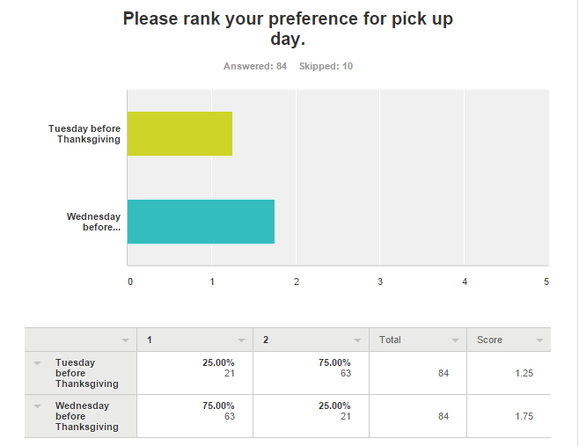

4.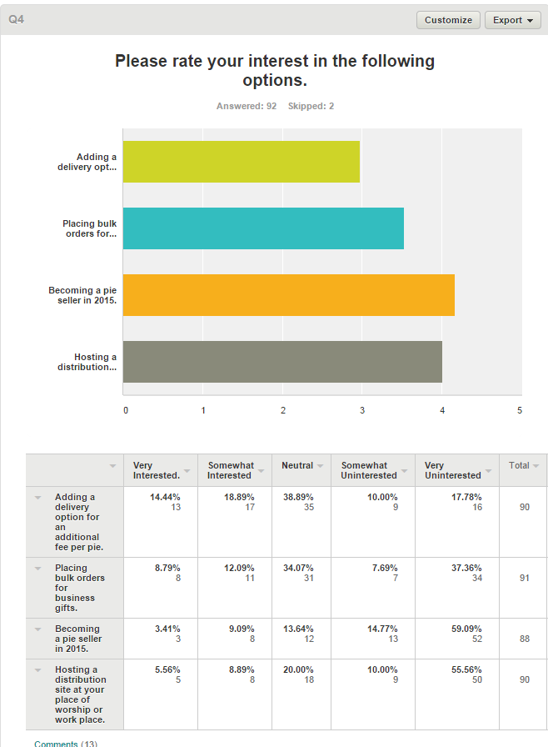

Comments:
- My Church is already a Distrubution Site.
- If I were to buy for gifts, I would want more information about the pie ahead of time. I had the most delicious pecan pie with chocolate molded leaves on top that I would gift to everyone I know!
- We both work from home, so a workplace distribution site is not an option. However, we would happily display and distribute brochures or fliers.
- My thought is to invite Rotary Clubs to take part since so many clubs deliver Meals On Wheels.
- None
- Would have liked something closer to Lake Highlands, but Coit and Spring Valley was good.
- I am a member of Highland Park Presbyterian Church. I would be more than happy to look into it if that location would help out your cause!
- Love that Spring Valley UMC is a distribution site!! :)
- The pies are awesome! I don't mind picking them up.
- What about an option to buy a pie for some of the seniors on the Meals on Wheels routes? Or can they now be purchased and designated to that end?
- I don't work outside the home, so I don't have a good distribution site
- Fortunate to have pickup at Spring Valley UMC, hope that continues.
- Depends upon location of the distribution centers. I found that the location I used was close to my delivery location, daughter's house that I was going to go to for thanksgiving dinner.

5.
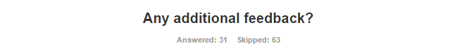
Comments:
- Wonderful program..Great work
- GREAT idea!!
- The pecan pie was delicious!!! And the pickup near downtown Dallas was very convenient and the people there were so nice.
- What a fabulous service/mission combo! Congratulations!!
- Are you doing it for Xmas? I would be interested.
- The receipt sent via email was not correct. I donated a "zero calorie" pie but the receipt said none of my purchase was tax deductible.
- I have told several people about the pie sale. My dentist told me to forward the email to him next time.
- Just thanks for all you do for the Seniors!
- Fantastic idea and a wonderful solution for busy families
- Would love to know the chef or restaurant that our pie came from so we can continue to support their business. My sister's pie had a business card under pie tin but there was not any identification with our pie.
- love the fund raiser; 2nd year to buy from you
- N/A
- Great project, very pleased, although the pies were pricey
- I really want to know what was on the top of the pumpkin pie? I expected a plain pumpkin pie.
- I think the Power of Pie is a fabulous idea! My pecan pie was absolutely delicious and enjoyed by all.
- Not really; great pies and very, very good organization.
- thank you for the opportunity to donate!
- Starting the order process a few months earlier up through November would be great, might have an opportuntity for more buyers.
- Thank you!
- You all did a great job!
- would like to know who baked the pie. maybe a business card or something. make it fun to know we had a pie from a top chef!
- When I retire I would like to volunteer for the VNA. That is only a couple of years away. Thank you for your hard work.
- As far as I could tell, this was a very well planned and executed project, and great to be a part of it as a volunteer, as well as a pie purchaser and eater!
- Power of Pie should be done on/around March 14, unofficial "Pie Day." Pi Day is an annual celebration commemorating the mathematical constant π (pi). Pi Day is observed on March 14 (or 3/14 in the month/day date format), since 3, 1, and 4 are the first three significant digits of π in decimal form. In 2009, the United States House of Representatives supported the designation of Pi Day
- Happy to see how much was raised by the Pie sales! Way to go!
- Very helpful volunteers made this a great process. Thanks.
- I loved the whole idea and being able to enjoy our pies, knowing how much they will benefit others. The only suggestion would be to add another pie choice? Apple?
- Glad you had success. Hope you had a nice bump from your first year. Bless you all.
- Would love to have apple pies as an option!!
- grateful to have the opportunity to bless someone with this service

